Relational Database Concepts

Aitrich Technologies Pvt. Ltd.
© All rights reserved.

Relational Database Concepts
A relational database matches data by using common characteristics found within the data set. The resulting groups of data are organized and are much easier for many people to understand. Strictly, a relational database is a collection of relations (frequently called tables). Other items are frequently considered part of the database, as they help to organize and structure the data, in addition to forcing the database to conform to a set of requirements. Relational databases are currently the predominant choice in storing data like financial records, medical records, personal information and manufacturing and logistical data. The software used to do this grouping is called a relational database management system (RDBMS). The term "relational database" often refers to this type of software.
The term relational database was originally defined by and is attributed to Edgar Codd at IBM Almaden Research Center in 1970.
Support for ACID Properties:
ACID properties are one of the important concepts for databases. ACID stands for Atomicity, Consistency, Isolation, and Durability. These properties of a DBMS allow safe sharing of data. Without these properties the inaccuracy in the data will be huge. With the help of the ACID properties the accuracy can be maintained.
Tables, Rows, and Columns
A table in a relational database, alternatively known as a relation, is a two dimensional structure used to hold related information. A Table is a basic storage structure of an RDBMS and consists of columns and rows. A table represents an entity. A database consists of one or more related tables.
NOTE
Don’t confuse a relation with relationships. A relation is essentially a table, and a relationship is a way to correlate, join, or associate the two tables.
A row in a table is a collection or instance of one thing, such as one employee or one line item on an invoice. It is also known as Tuple or Records.
A column contains all the information of a single type, and the piece of data at the intersection of a row and a column, a field, is the smallest piece of information that can be retrieved with the database’s query language. Column is also termed as Attribute. Columns represent the attributes of an object. Each column has a column name and contains values that are bound by the same type and size.
For example, a table with information about employees might have a column called LAST_NAME that contains all of the employees’ last names. Data is retrieved from a table by filtering on both the row and the column.
The following picture illustrates the relational database components.
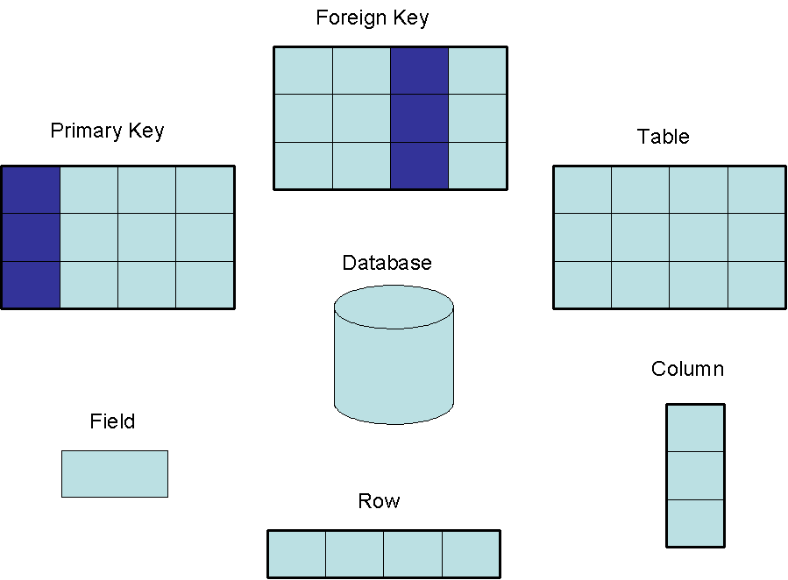
Figure 1.1 Relational Database concepts

One item of data, such as single phone number of a person is called as a Data Value or Field. A Field is an intersection of a row and a column. A field contains one data value. If there is no data in the field, the field is said to contain a NULL value.

Table 1.1 illustrates some of these relational database concepts. . It has five columns and six rows, with each row representing a different employee.
Table 1.1: Employees
Employee_Number | First_name | Last_Name | Date_of_Birth | Car_Number
10001 | Axel | Washington | 28-Aug-43 | 5
10083 | Arvid | Sharma | 24-Nov-54 | null
10120 | Jonas | Ginsberg | 01-Jan-69 | null
10005 | Florence | Wojokowski | 04-Jul-71 | 12
10099 | Sean | Washington | 21-Sep-66 | null
10035 | Elizabeth | Yamaguchi | 24-Dec-59 | null

Views
By definition, a database view or view is a virtual or logical table which is composed of result set of a SELECT query. In database theory, a view consists of a stored query accessible as a virtual table composed of the result set of a query. Any relation that is not part of the logical model, but is made visible to a user as a virtual relation, is called a view. Unlike ordinary tables (base tables) in a relational database, a view does not form part of the physical schema: it is a dynamic, virtual table computed or collated from data in the database. Changing the data in a table alters the data shown in subsequent invocations of the view. Database users can manipulate nested views, thus one view can aggregate data from other views.
View names may appear in any place where a relation name may appear, so long as no update operations are executed on the views.
Once we defined a view, we can use the view name to refer to the virtual relation that the view generates. At any time, the set of tuples in the view relation is the result of evaluation of the query expression that defines the view at that time. If the view relation is computed and stored, it may become out of date if the relations used to define it are modified. To avoid this, views are usually implemented as when we define a view, the database system stores the definition of the view itself, rather than the result of evaluation of the relational-algebra expression that defines the view. Wherever a view relation appears in a query, it is replaced by the stored query expression. Some database systems allow view relations to be stored, but they make sure that, if the actual relations used in the view definition change, the view is kept up to date. Such views are called materialized views. The process of keeping up to date is called view maintenance.
Views can provide advantages over tables:
- Views can represent a subset of the data contained in a table
- Views can join and simplify multiple tables into a single virtual table
- Views can act as aggregated tables, where the database engine aggregates data (sum, average etc) and presents the calculated results as part of the data
- Views can hide the complexity of data; for example a view could appear as Sales2000 or Sales2001, transparently partitioning the actual underlying table
- Views take very little space to store; the database contains only the definition of a view, not a copy of all the data it presents
- Depending on the SQL engine used, views can provide extra security
- Views can limit the degree of exposure of a table or tables to the outer world

Integrity Rules
Relational tables follow certain integrity rules to ensure that the data they contain stay accurate and are always accessible. First, the rows in a relational table should all be distinct. If there are duplicate rows, there can be problems resolving which of two possible selections is the correct one. For most DBMSs, the user can specify that duplicate rows are not allowed, and if that is done, the DBMS will prevent the addition of any rows that duplicate an existing row.
A second integrity rule of the traditional relational model is that column values must not be repeating groups or arrays. A third aspect of data integrity involves the concept of a null value.
    - Required data
    - Entity integrity
    - Referential integrity

Required Data
A database takes care of situations where data may not be available by using a null value to indicate that a value is missing. It does not equate to a blank or zero. A blank is considered equal to another blank, a zero is equal to another zero, but two null values are not considered equal. A null is used to represent data that is either not available, missing, or not applicable.
In a database some columns must contain a valid value; they are not allowed to contain nulls.
The ISO std provides the NOT NULL column specifier to provide this type of constraint. When NOT NULL is specified, the system rejects any attempt to insert a null in the column.
If NULL is specified, the system accepts nulls. The ISO default is null.

Entity Integrity
- Unique key Constraint
- Primary key Constraint

Unique key Constraint
A key consists of one or more columns.
Usage of the unique key constraint is to prevent the duplication of values within the rows of a specified column or a set of columns in a table. Columns defined with this constraint can also allow null values.
- Primary key Constraint
When each row in a table is different, it is possible to use one or more columns to identify a particular row. This unique column or group of columns is called a primary key. A primary key uniquely defines a relationship within a database. In order for an attribute to be a good primary key it must not repeat. Any column that is part of a primary key cannot be null; if it were, the primary key containing it would no longer be a complete identifier. This rule is referred to as entity integrity. A table can have only one primary key.
For example, the primary key for the table1.1 Employees would generally be the Employee_Number because each one is guaranteed to be different. (A number is also more efficient than a string for making comparisons.) It would also be possible to use First_Name and Last_Name because the combination of the two also identifies just one row in our sample database. Using the last name alone would not work because there are two employees with the last name of "Washington." In this particular case the first names are all different, so one could conceivably use that column as a primary key, but it is best to avoid using a column where duplicates could occur. If Elizabeth Taylor gets a job at this company and the primary key is First_Name, the RDBMS will not allow her name to be added (if it has been specified that no duplicates are permitted). Because there is already an Elizabeth in the table, adding a second one would make the primary key useless as a way of identifying just one row. Note that although using First_Name and Last_Name is a unique composite key for this example, it might not be unique in a larger database.

Referential Integrity

The referential integrity constraints states that a tuple in one relation that refers to another relation must refer to an existing tuple in that relation.

Given two relations R & S, suppose R refers to the relation S via a set of attributes that forms the primary key of S and this set of attributes forms a foreign key in R. Then the value of the foreign key in a tuple in R must either be equal to the primary key of a tuple of S or be entirely null.
- Foreign keys
A relation schema may have an attribute that corresponds to the primary key of another relation. The attribute is called a foreign key.
  - E.g. customer_name and account_number attributes of depositor are foreign keys to customer and account respectively.
Only values occurring in the primary key attribute of the referenced relation may occur in the foreign key attribute of the referencing relation.
Figure 1.2 Schema diagram
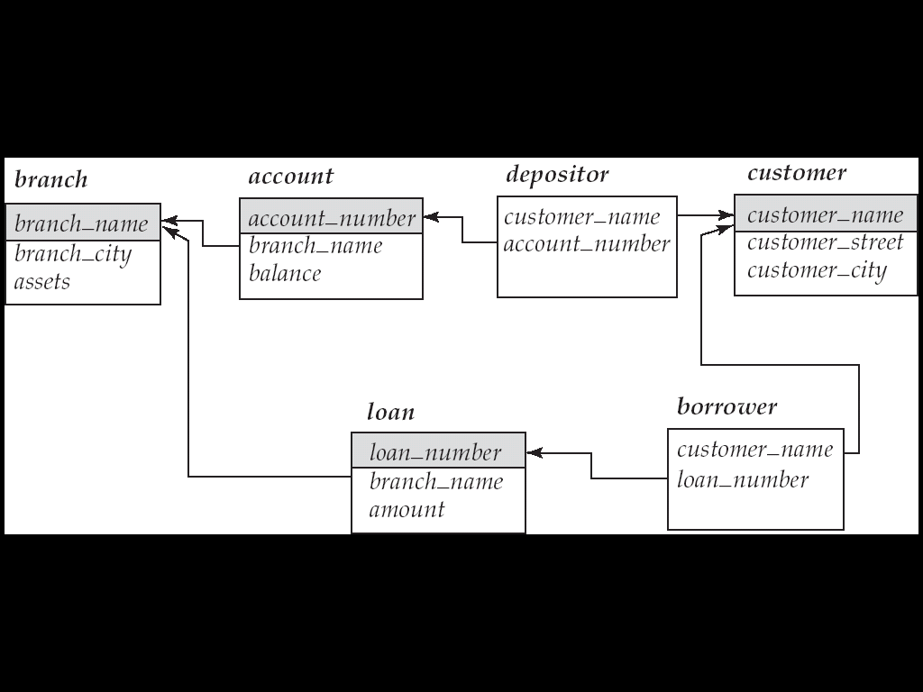
Indexes
An index in a database resembles an index at the back of a book.
A database index is a data structure that improves the speed of data retrieval operations on a database table at the cost of slower writes and increased storage space. Indexes can be created using one or more columns of a database table, providing the basis for both rapid random lookups and efficient access of ordered records. The disk space required to store the index is typically less than that required by the table (since indices usually contain only the key-fields according to which the table is to be arranged, and exclude all the other details in the table), yielding the possibility to store indices in memory for a table whose data is too large to store in memory.
In a relational database, an index is a copy of one part of a table. Some databases extend the power of indexing by allowing indices to be created on functions or expressions. For example, an index could be created on upper(last_name), which would only store the upper case versions of the last_name field in the index.
Index Architecture
Index architectures can be classified as clustered or non-clustered.

Non-clustered
The data is present in random order, but the logical ordering is specified by the index. The data rows may be randomly spread throughout the table. The non-clustered index tree contains the index keys in sorted order, with the leaf level of the index containing the pointer to the page and the row number in the data page. In non-clustered index:
- The physical order of the rows is not the same as the index order.
- Typically created on column used in JOIN, WHERE, and ORDER BY clauses.
- Good for tables whose values may be modified frequently.
Microsoft SQL Server creates non-clustered indices by default when CREATE INDEX command is given. There can be more than one non-clustered index on a database table. There can be as many as 249 non-clustered indexes per table. It also creates a clustered index on a primary key by default.

Clustered
Clustering alters the data block into a certain distinct order to match the index, resulting in the row data being stored in order. Therefore, only one clustered index can be created on a given database table. Clustered indices can greatly increase overall speed of retrieval, but usually only where the data is accessed sequentially in the same or reverse order of the clustered index, or when a range of items is selected.
Since the physical records are in this sort order on disk, the next row item in the sequence is immediately before or after the last one, and so fewer data block reads are required. The primary feature of a clustered index is therefore the ordering of the physical data rows in accordance with the index blocks that point to them. Some databases separate the data and index blocks into separate files, others put two completely different data blocks within the same physical file(s). Create an object where the physical order of rows is same as the index order of the rows and the bottom(leaf) level of clustered index contains the actual data rows.
Normalization:
Normalization is a design technique which helps to design the relational databases. Normalization is essentially a two step process that puts data into tabular form by removing redundant data from the relational tables. A basic goal of normalization is to create a set of relational tables that are free of redundant data and the data should be consistent.
Normalization of data is a process of decomposing unsatisfactory relation schemas into smaller relation schemas that possess desirable property. The process of normalization was first developed by E.F.Codd. Normalization is often executed as a series of steps. Each step corresponds to a specific normal form that has known properties. A table that contains one or more repeating groups can be called as unnormalized form. Normalization is a multi-step process beginning with an “unnormalized” relation
Normal Forms
- First Normal Form (1NF)
- Second Normal Form (2NF)
- Third Normal Form (3NF)
- Boyce-Codd Normal Form (BCNF)
- Fourth Normal Form (4NF)
- Fifth Normal Form (5NF)
Unnormalized Relations:
First step in normalization is to convert the data into a two-dimensional table. In unnormalized relations data can repeat within a column. We are going to explain with the help of Hospital Example.
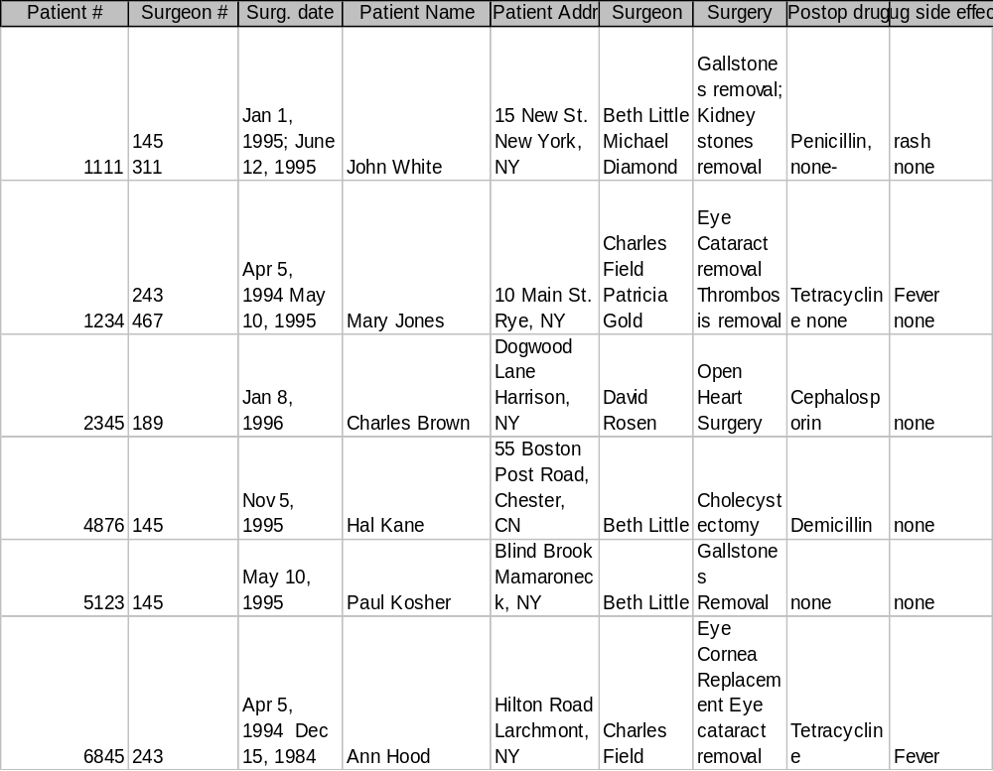
Figure 1.3 Un-normalized form

First Normal Form:
First Normal Form disallows multivalued attributes, composite attributes and their combinations. It states that the domain of an attribute must include only atomic ( simple Indivisible ) values and that the value of any attribute in a tuple must be a single value from the domain of that attribute. ie First Normal Form is a relation in which the intersection of each row and column contains one and only one value.
For the above example figure 1.3, to move to First Normal Form a relation must contain only atomic values at each row and column.
  - No repeating groups
  - A column or set of columns is called a Candidate Key when its values can uniquely identify the row in the relation.
Now, figure 1.4 shows the first normal form for the above example.

Figure 1.4 First Normal Form
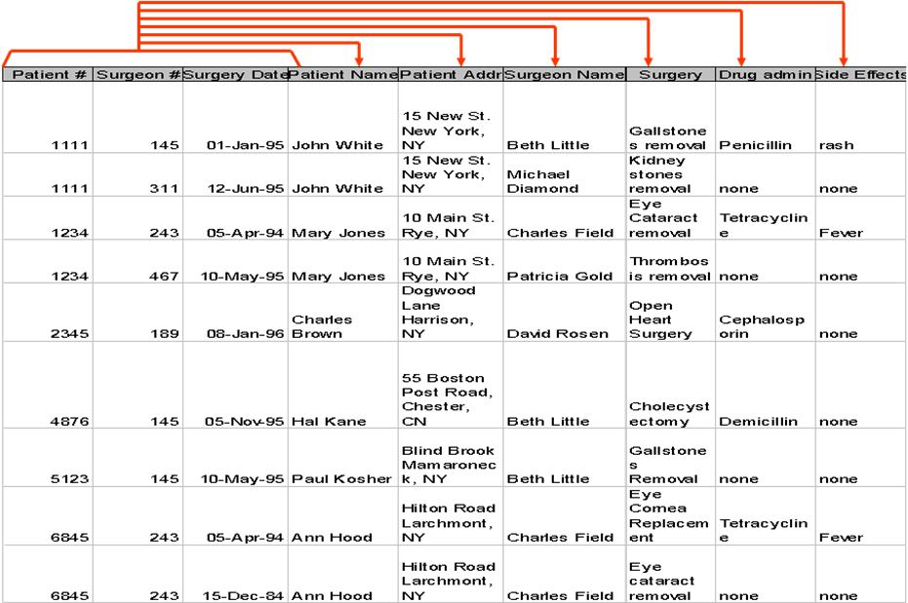
Second Normal Form
1NF Storage anomalies:
- Insertion: A new patient has not yet undergone surgery -- hence no surgeon # -- Since surgeon # is part of the key we can’t insert.
- Insertion: If a surgeon is newly hired and hasn’t operated yet -- there will be no way to include that person in the database.
- Update: If a patient comes in for a new procedure, and has moved, we need to change multiple address entries.
- Deletion (type 1): Deleting a patient record may also delete all info about a surgeon.
- Deletion (type 2): When there are functional dependencies (like side effects and drug) changing one item eliminates other information.
Here the solution, Second Normal Form (2 NF).
A relation is said to be in Second Normal Form when every non-key attribute is fully functionally dependent on the primary key.
  - That is, every non-key attribute needs the full primary key for unique identification
Second normal form (2NF) is a relation that is in 1NF and every non-prime attribute is fully functionally dependent on the primary key. The normalization of 1NF relations to 2NF involves the removal of partial dependencies.
- Full Functional Dependency :
A dependency from X →Y is said to be a full functional dependency if removal of some value from X means the dependency will no more hold
- Partial Functional Dependency :
A dependency from X →Y is said to be partial functional dependency if removal of some attribute from X the dependency still holds. ( i.e.. The value of Y attribute can be determines by a part of X attributes)
For the above example, the second normal form will be as shown below:
Figure 1.5 Patients
Figure 1.6 Surgeons

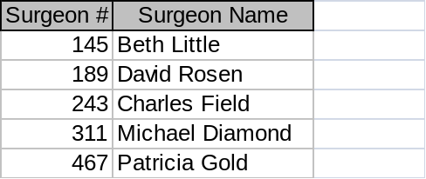

Figure 1.7 Surgeries


1NF Storage anomalies removed:
- Insertion: Can now enter new patients without surgery.
- Insertion: Can now enter Surgeons who haven’t operated.
- Deletion (type 1): If Charles Brown dies the corresponding tuples from Patient and Surgery tables can be deleted without losing information on David Rosen.
- Update: If John White comes in for third time, and has moved, we only need to change the Patient table
Third Normal Form:
2NF Storage anomalies:
- Insertion: Cannot enter the fact that a particular drug has a particular side effect unless it is given to a patient.
- Deletion: If John White receives some other drug because of the penicillin rash, and a new drug and side effect are entered, we lose the information that penicillin can cause a rash
- Update: If drug side effects change (a new formula) we have to update multiple occurrences of side effects.
Here comes the Third Normal Form
A relation is said to be in Third Normal Form if there is no transitive functional dependency between non-key attributes. When one nonkey attribute can be determined with one or more nonkey attributes there is said to be a transitive functional dependency.
- The side effect column in the Surgeries table is determined by the drug administered
  - Side effect is transitively functionally dependent on drug so Surgery is not 3NF
Third Normal Form is based on the concept of Transitive dependency. A functional dependency X →Y in a relation schema R is a transitive dependency if there is a set of attributes Z that is neither a candidate key nor a subset of any key of R, and both X →Z and Z →Y holds.

The third normalized relation of Figure 1.7 Surgeries will as shown below:
Figure 1.8 Surgeries
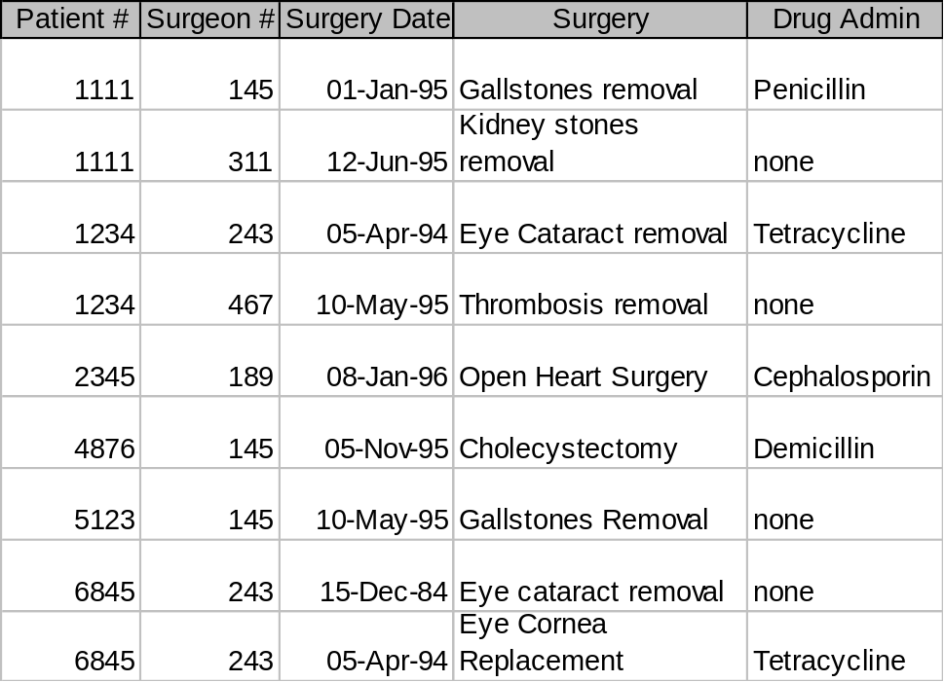

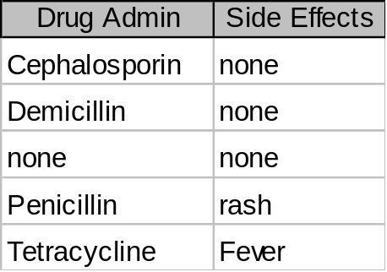Figure 1.9 Drugs

De-normalization
Normalization to death:
Normalization splits database information across multiple tables. To retrieve complete information from a normalized database, the JOIN operation must be used. JOIN tends to be expensive in terms of processing time, and very large joins are very expensive.
Denormalization is the process of attempting to optimize the read performance of a database by adding redundant data or by grouping data. In some cases, denormalization helps cover up the inefficiencies inherent in relational database software. A relational normalized database imposes a heavy access load over physical storage of data even if it is well tuned for high performance.
A normalized design will often store different but related pieces of information in separate logical tables (called relations). If these relations are stored physically as separate disk files, completing a database query that draws information from several relations (a join operation) can be slow. If many relations are joined, it may be prohibitively slow. There are two strategies for dealing with this. The preferred method is to keep the logical design normalized, but allow the database management system (DBMS) to store additional redundant information on disk to optimize query response. In this case it is the DBMS software's responsibility to ensure that any redundant copies are kept consistent. This method is often implemented in SQL as indexed views (Microsoft SQL Server) or materialized views (Oracle). A view represents information in a format convenient for querying, and the index ensures that queries against the view are optimized.
The more usual approach is to denormalize the logical data design. With care this can achieve a similar improvement in query response, but at a cost—it is now the database designer's responsibility to ensure that the denormalized database does not become inconsistent.
A denormalized data model is not the same as a data model that has not been normalized, and denormalization should only take place after a satisfactory level of normalization has taken place and that any required constraints and/or rules have been created to deal with the inherent anomalies in the design
Popular DBMS
MySQL
MySQL is a relational database management system (RDBMS) that runs as a server providing multi-user access to a number of databases. MySQL is the world's most popular open source database software, with over 100 million copies of its software downloaded or distributed throughout its history. The MySQL development project has made its source code available under the terms of the GNU General Public License, as well as under a variety of proprietary agreements. Free-software projects that require a full-featured database management system often use MySQL. MySQL is a key part of LAMP (Linux, Apache, MySQL, PHP / Perl / Python), the fast-growing open source enterprise software stack. MySQL is also used in many high-profile, large-scale World Wide Web products, including Wikipedia, Google (though not for searches) and Face book.
MySQL is written in C and C++. Many programming languages with language-specific APIs include libraries for accessing MySQL databases. These include MySQL Connector/Net for integration with Microsoft's Visual Studio (languages such as C# and VB are most commonly used) and the ODBC driver for Java.
SQL Server
Microsoft SQL Server is a relational model database server produced by Microsoft. Its primary query languages are T-SQL and ANSI SQL. SQL Server is commonly used as the backend system for websites and corporate CRMs and can support thousands of concurrent users. Server based database systems are designed to run on a central server, so that multiple users can access the same data simultaneously. The users normally access the database through an application.
Oracle
The Oracle Database (commonly referred to as Oracle RDBMS or simply as Oracle) is an object-relational database management system(ORDBMS) produced and marketed by Oracle Corporation.

